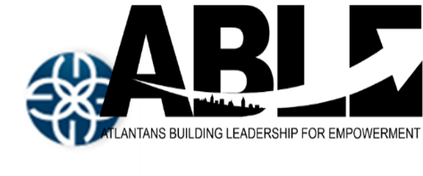 | 5300 Memorial Drive STE 216  Stone Mountain GA  4045436334  www.ablega.org

CONTACT: Angela Saxton FOR IMMEDIATE RELEASE: 1/26/2017
Lead Organizer
4045436334
Ablebuildingatl@gmail.com

Faith Leaders Across the Nation Unite for Criminal Justice Reform. End Mass Incarceration!

Atlanta, GA: As the nation celebrates the work of Dr. Martin Luther King, Jr. and at the opening of state legislative sessions, faith leaders from the Gamaliel Network are taking action in their cities and state capitols to promote public policies to dismantle the system of mass incarceration. In Atlanta, leaders are launching a multi-pronged campaign for restorative justice; in Madison, leaders are working to end “crimeless revocation of parole;” and in Jefferson City, leaders from St. Louis will be promoting “Raise the Age,” a policy which increases the age that a person can be automatically criminally charged as an adult from 17 to 18 years of age. Meanwhile, in Kansas City, leaders will hold a press conference to announce the plans of City Councilman Jermaine Reed to file an ordinance to expand the city’s “Ban the Box” policy, which removes criminal history questions off of applications.

ABLE on January 17th, will stand in solidarity with leaders across the nation taking action to promote equitably public policies to dismantle the mass incarceration within the criminal justice system. ABLE’s press conference will focus on launching a multi-pronged campaign for restorative justice such as the criminalization of traffic violations and inequitable fines and fees within the Georgia criminal justice system.

ABLE Stands on the Belief That:
“The right to human dignity is inalienable and when compromised or denied they have the legal and moral right to restoration. That as a Faith-Based Organizing organization it is our moral imperative to help those made vulnerable by injustice. That as A.B.L.E. Leaders, we will take the lead and in partnership with others to demand justice, equality, and dignity for all people.”
-Rev Ronald Bonner-

The January 17 press conference will be held at St John’s Lutheran Church, 1410 Ponce De Leon Ave Ne Atlanta GA 30307

ABLE is an interfaith social justice organization committed to developing and empowering ordinary people to become leaders who effect change for the common good of all across the region.

###

